

Project Name: TravelGo

Branch PG-DAC March-2023

Documentation On

**“TravelGo”**

PG-DAC SEPT 2022

**Guided By: Bakul Joshi**

Submitted By :

**Group No: 04**

* **Kumbhar Samruddha Rajkumar 230343020049**
* **Malkar Pranav Ramkrishna 230343020058**
* **Patil Sachin Vilas 230343020072**
* **Sonone Prithvijeet Santosh 230343020090**

**v**

**Table of Contents**

**1. Introduction 5**

1.1 Document Purpose **5**

1.2 Project Background **5**

1.3 Aim & Objectives **5**

**2. Business Requirements Overview**…………………………………………………………**6**

**3.Functional Requirements** **6**

3.1 TravellerModule **6**

3.2 Property owner Module **6**

3.3 Admin Module **7**

**4.Non-Functional Requirement………………………………………………………………..7**

**5. Use Case Diagram 8**

5.1 Admin **8**

5.2 Traveller **9**

5.3 Host **10**

**6. Database Design 11**

1 Login **11**

2 Role **11**

3 Traveller………………………………………………………………………………… **11**

4 Properties **12**

5 Host **12**

6 Booking **12**

7 Subscription **13**

8 Sub_payment **13**

9 Book_payment **13**

10Ammenities **13**

11Admin **14**

**7. E-R Diagram………………………………………………………………………………………15**

**8. Snapshots 16**

**9. Conclusion 25**

**List of Figures**

**Use Case Diagrams 17**

Fig 1 Admin 8

Fig 2 Traveller 9

Fig 3 Host 10

Fig 4 ER Diagram 14

1. Introduction:
   1. Document Purpose:

This document communicates the business requirements and scope for developing

TravelGo . The scope of this document is to define the functional and non functional requirements, business rules and other constraints requirements.

## Project Background:

There is a need for a platform that allows users to easily find and book accommodations for their travel needs. Similar to Airbnb, TravelGo aims to provide a user-friendly website where travelers can search for available accommodations and property owners can list their properties for rent.

## Aim & Objectives:

The main objective of this project is to develop a website that connects travelers and property owners, allowing travelers to find suitable accommodations and property owners to monetize their properties. TravelGo aims to provide a seamless and efficient platform for booking accommodations for various travel purposes.

1. **Business Requirements Overview:**

* TravelGo is a public web application.
* TravelGo will be open to a Indian audience, with a focus on providing services in all over the countries.
* The primary users of TravelGo are travelers and property owners.
* Travelers can search for available accommodations based on their preferences.
* Property owners can list their properties and provide details such as location, amenities, pricing, and availability.
* TravelGo provides functions that connect travelers and property owners efficiently.
* TravelGo will include an administrative module to manage the system.

# Functional Requirements Overview:

TravelGo consists of several modules described below.

1. Traveler Module
2. Property Owner Module
3. Admin Module

# **3.1 Traveller Module**

* + Travelers can register and create their own accounts.
  + Travelers can search for accommodations based on location, preferences.
  + Travelers can view detailed property listings, including descriptions, amenities, photos, and reviews.
  + Travelers can book accommodations and make payments securely.

# **Property owner Module**

* Property owners can register and create their own accounts.
* Property owners can list their properties by providing details such as location, amenities, pricing, and availability.
* Property owners can manage their property listings.
* Property owner can add multiple property according to the taken subscription.

# **3.3 Admin Module**

* The administrative module allows system administrators to manage the overall system.
* Administrators can manage user accounts and ensure their authenticity.
* Administrators can monitor system performance and generate reports.
* Admin can check the status and can change it.

1. **Non-Functional Requirement:**

* The website should have a professional design, look and feel, and color scheme.
* Users will have no limitations for accessing the application through the internet. The system should be designed to support a large number of concurrent users.
* The site must follow general usability guidelines for menus, navigation, colors, links, and other actions provided on the screens.
* The system should be designed to ensure a seamless user experience, allowing users to complete tasks efficiently and intuitively

.

## 5. Use-Case Diagram

**5.1 Admin:**

Fig. Use-Case Diagram for Admin

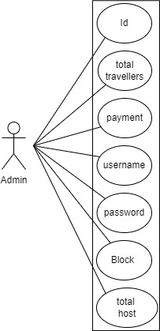

## 5.2 Traveller:

Fig. Use-Case Diagram for Traveller

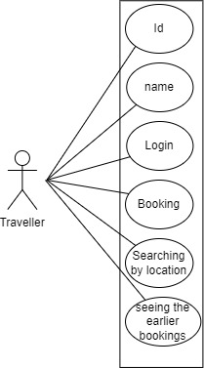

**5.3 Host:**

Fig. Use-Case Diagram for Host

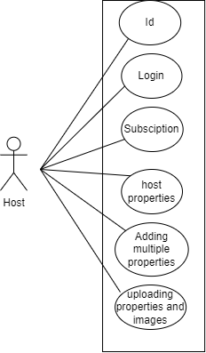

**6. Database Design:**

1. **login table**

|  |  |  |  |  |  |
| --- | --- | --- | --- | --- | --- |
|  | | | | | |
| Field | Type | Null | Key | Default | Extra |
|
| login_id | int | NO | PRI | NULL | auto_increment |
| name | varchar(45) | NO | MUL | NULL |  |
| pwd | varchar(45) | NO |  | NULL |  |
| role_id | int | YES | MUL | NULL |  |
| Staus | int | NO |  | NULL |  |

**2] role table**

|  |  |  |  |  |  |
| --- | --- | --- | --- | --- | --- |
|  | | | | | |
| Field | Type | Null | Key | Default | Extra |
|
| Id_role | int | NO | PRI | NULL | auto_increment |
| type | varchar(45) | NO |  | NULL |  |

**3] traveller table**

|  |  |  |  |  |  |
| --- | --- | --- | --- | --- | --- |
|  | | | | | |
| Field | Type | Null | Key | Default | Extra |
|
| Id_traveller | int | NO | PRI | NULL | auto_increment |
| t_name | varchar(45) | NO |  | NULL |  |
| Password | varchar(45) | YES |  | NULL |  |
| Gender | varchar(45) | YES |  | NULL |  |
| Emailid | int | YES |  | NULL |  |
| Id_login | varchar(45) | YES | MUL | NULL |  |

**4] properties table**

|  |  |  |  |  |  |
| --- | --- | --- | --- | --- | --- |
|  | | | | | |
| Field | Type | Null | Key | Default | Extra |
|
| Id_properties | int | NO | PRI | NULL | auto_increment |
| Address | varchar(100) | NO | UNI | NULL |  |
| State | Varchar(45) | NO |  | NULL |  |
| City | Varchar(45) | NO |  | NULL |  |
| Price | Int | NO |  | NULL |  |
| Id_host | Int | NO | MUL | NULL |  |
| Id_ammenity | Int | NO | MUL | NULL |  |
| pictures | varchar(100) | YES |  | NULL |  |

**5] Booking table**

|  |  |  |  |  |  |
| --- | --- | --- | --- | --- | --- |
|  | | | | | |
| Field | Type | Null | Key | Default | Extra |
|
| id_booking | int | NO | PRI | NULL | auto_increment |
| Prop_id | Int | YES | MUL | NULL |  |
| Travel_id | Int | YES | MUL | NULL |  |
| Checkin | Date | YES |  | NULL |  |
| Checkout | Date | YES |  | NULL |  |
| Totalfare | int | YES | MUL | NULL |  |

**6] Host table**

|  |  |  |  |  |  |
| --- | --- | --- | --- | --- | --- |
|  | | | | | |
| Field | Type | Null | Key | Default | Extra |
|
| Id_host | int | NO | PRI | NULL | auto_increment |
| Name | varchar(200) | YES |  | NULL |  |
| Password | varchar(45) | YES |  | NULL |  |
| Gender | varchar(45) | YES |  | NULL |  |
| Email | Varchar(45) | YES |  | NULL |  |
| Sub_id | Int | YES | MUL | NULL |  |
| count | Int | YES |  | NULL |  |
| Id_login | Int | YES | MUL | NULL |  |

**7] Subscription table**

|  |  |  |  |  |  |
| --- | --- | --- | --- | --- | --- |
|  | | | | | |
| Field | Type | Null | Key | Default | Extra |
|
| Sub_id | Int | NO | PRI | NULL | auto_increment |
| Amount | int | YES |  | NULL |  |
| Validity | Date | YES |  | NULL |  |
| props | int | YES |  |  |  |

**8] Sub_Payment table**

|  |  |  |  |  |  |
| --- | --- | --- | --- | --- | --- |
|  | | | | | |
| Field | Type | Null | Key | Default | Extra |
|
| id | int | NO | PRI | NULL | auto_increment |
| Id_host | int | NO | MUL | NULL |  |
| Amount | Int | YES |  | NULL |  |
| payMode | varchar(45) | YES |  | NULL |  |

**9] Booking_Payment table**

|  |  |  |  |  |  |
| --- | --- | --- | --- | --- | --- |
|  | | | | | |
| Field | Type | Null | Key | Default | Extra |
|
| Id_book | int | NO | PRI | NULL | auto_increment |
| Booking_id | int | YES | MUL | NULL |  |
| Pay_mode | Varchar(45) | YES |  | NULL |  |
| amount | int | NO |  | NULL |  |

**10] Ammenitites table**

|  |  |  |  |  |  |
| --- | --- | --- | --- | --- | --- |
|  | | | | | |
| Field | Type | Null | Key | Default | Extra |
|
| Id | int | NO | PRI | NULL |  |
| Room | varchar(45) | YES |  | NULL |  |
| Home_type | varchar(45) | YES |  | NULL |  |
| Bedrooms | int | NO |  | NULL |  |
| Has_kitchen | Tinyint | YES |  | NULL |  |
| Has_ac | Tinyint | YES |  | NULL |  |
| Has_parking | Tinyint | YES |  | NULL |  |
| Has_tv | Tinyint | YES |  | NULL |  |
| Has_caretaker | Tinyint | YES |  | NULL |  |
| Summary | Varchar(200) | YES |  | NULL |  |

**11] Admin table**

|  |  |  |  |  |  |
| --- | --- | --- | --- | --- | --- |
|  | | | | | |
| Field | Type | Null | Key | Default | Extra |
|
| Id | int | NO | PRI | NULL | auto_increment |
| Fname | varchar(45) | NO |  | NULL |  |
| Lname | varchar(45) | NO |  | NULL |  |
| Username | varchar(45) | YES |  | NULL |  |
| Password | varchar(45) | YES |  | NULL |  |
| Contact | Bigint | NO |  | NULL |  |
| emailid | Varchar(45) | NO |  | NULL |  |

## ER-Diagram:

**E-R diagram shows database of TravelGo**

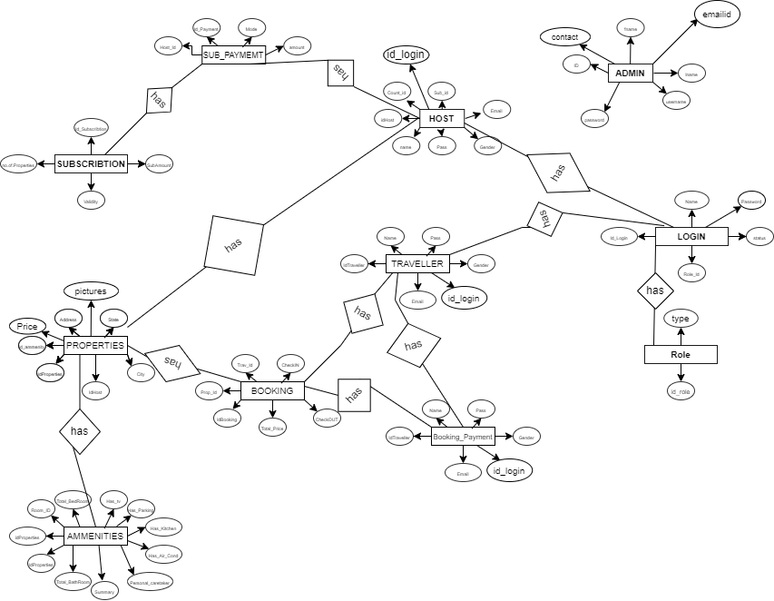

**8. Snapshots:**

**8.1 Home Page:**

Following snapshot shows the Home page for TravelGo before Login.

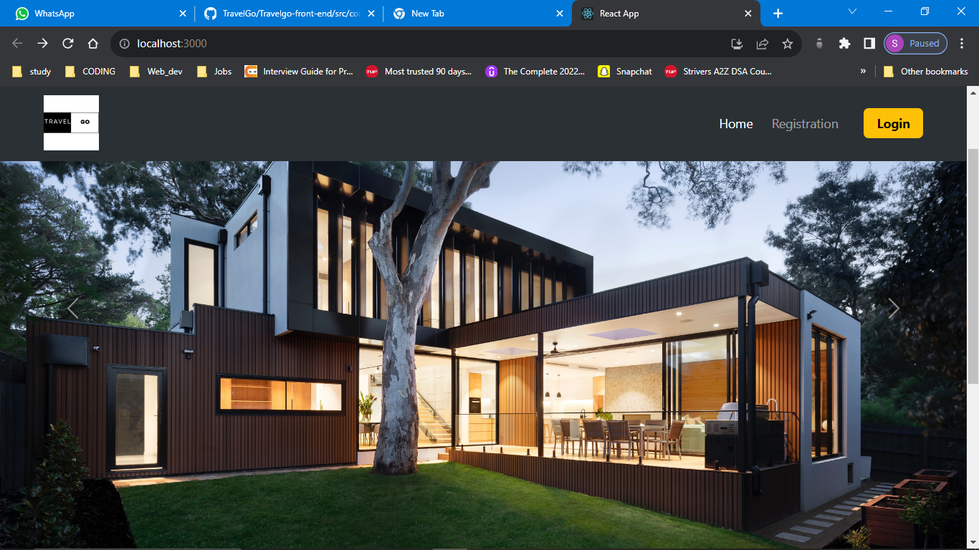

This page contains following controls

* Home
* Registration
* Login Button

This page also contains footer consisting information about the website and contact us details.

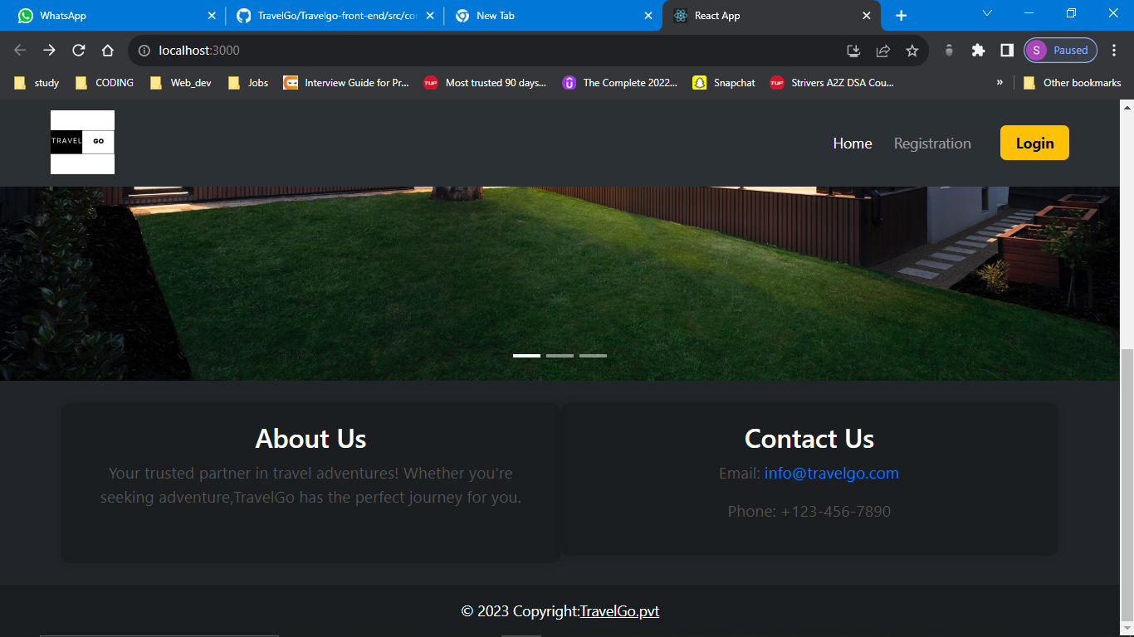

**8.2 Login Page**

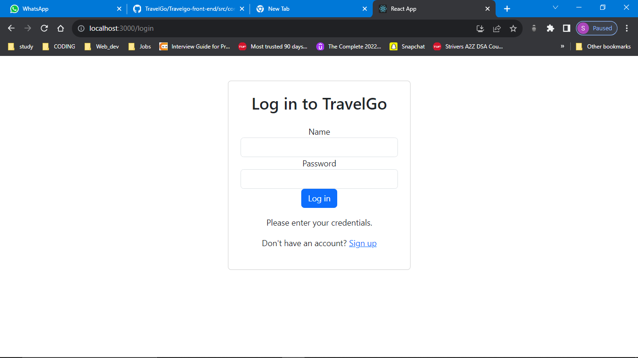

**8.4 Admin Home Page**

**8.4.1 Check the status and modify it**

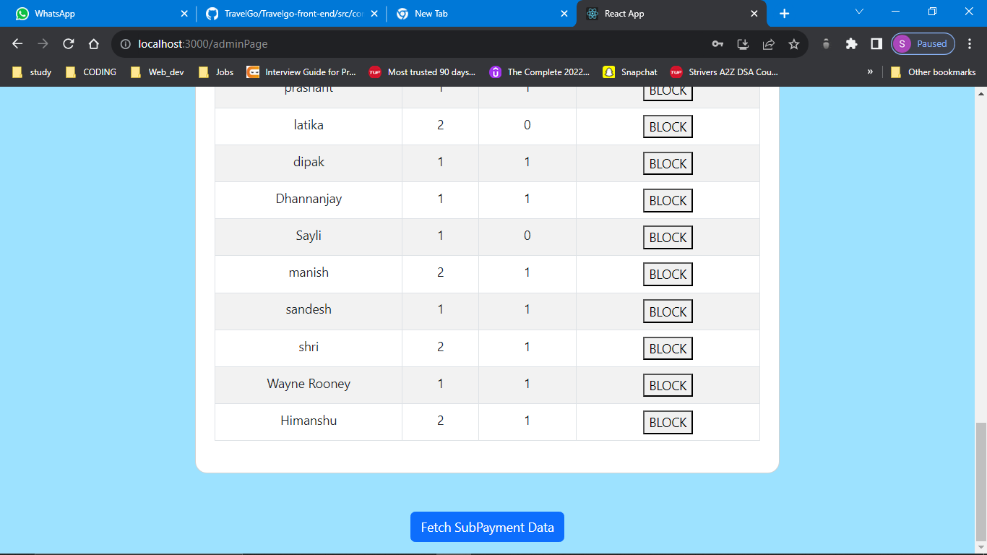

**8.4.2 Fetching the payment Data**

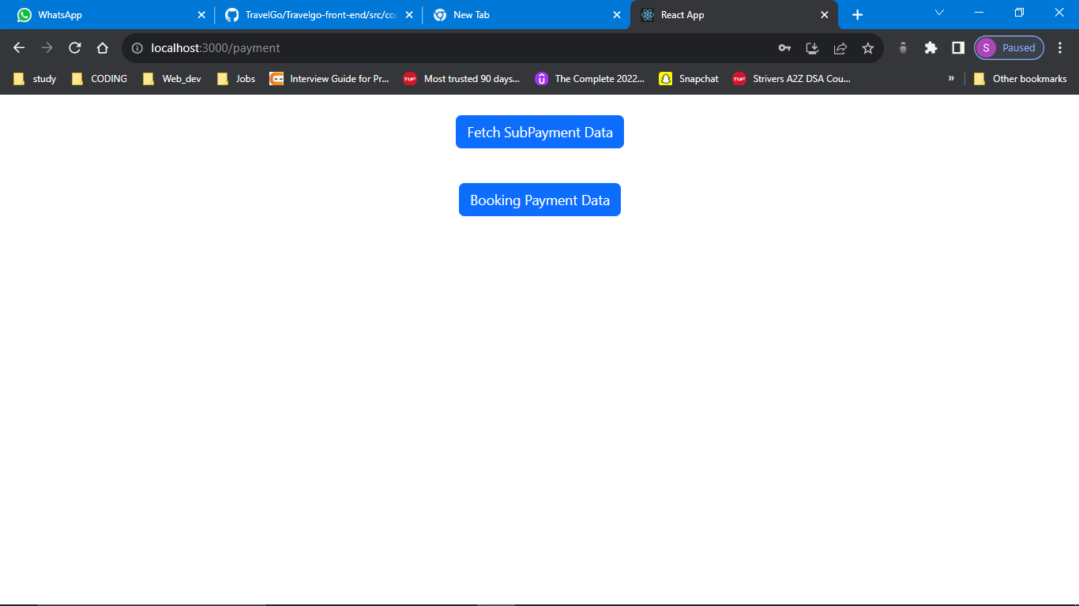

**8.5Traveller Home Page**

**8.5.1 Traveller Registration**

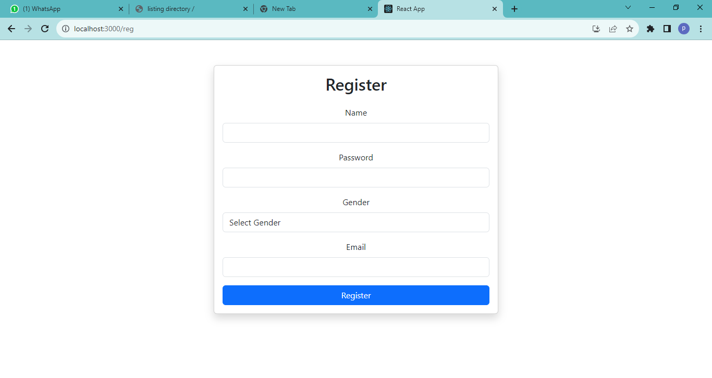

**8.5.2 Home**

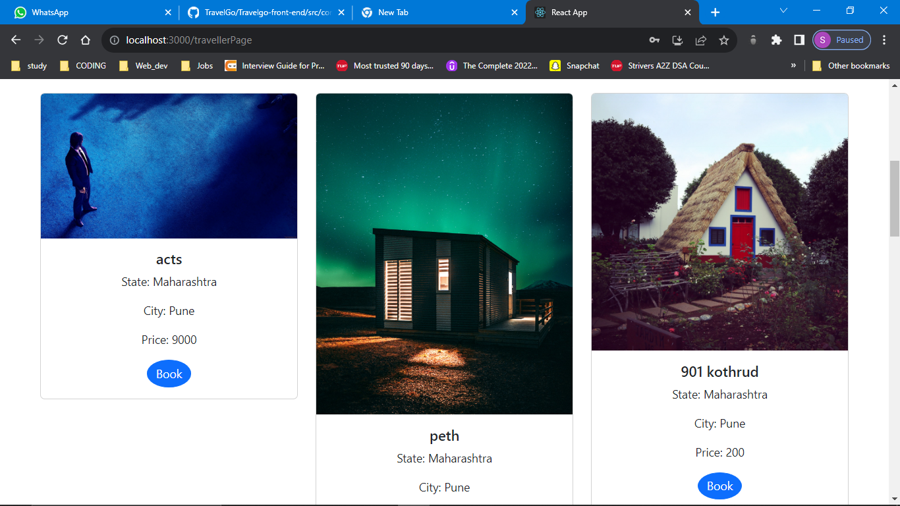

**8.5.2 Booking**

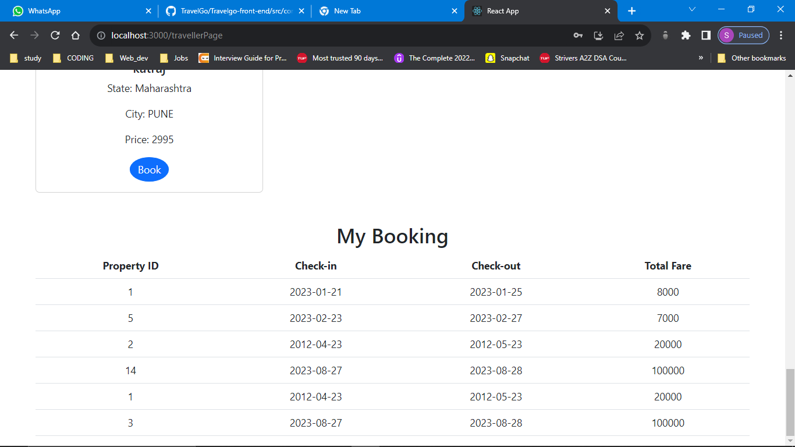

**8.5.3 Search**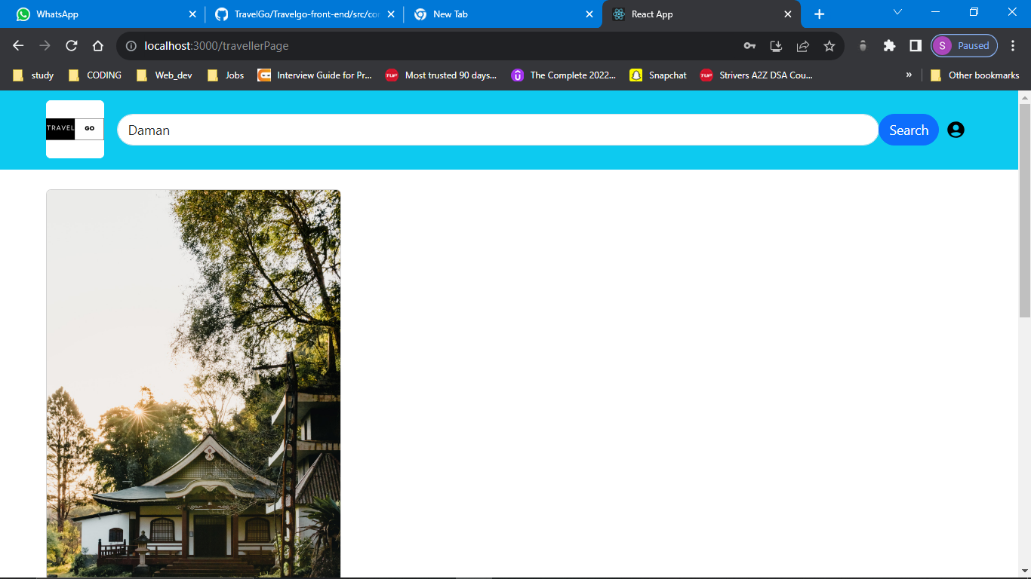

**8.6 Host**

**8.6.1 Host Registration**

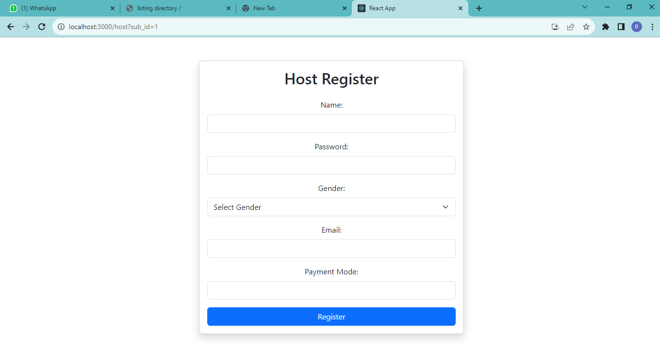

**8.6.2 Host Home page**

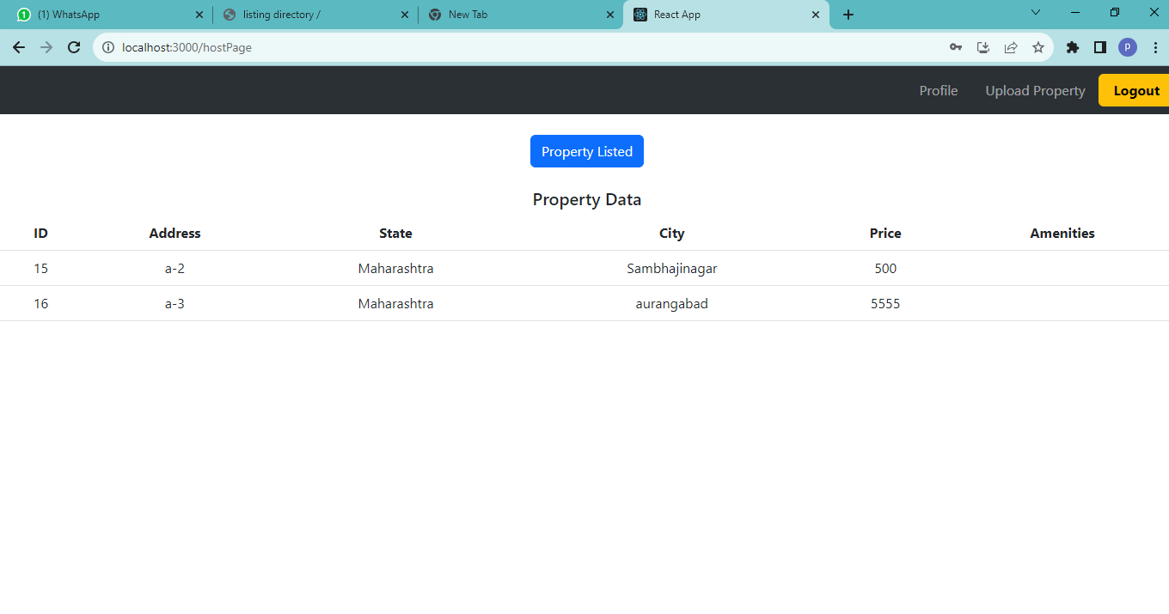

**8.6.3 Subscription type**

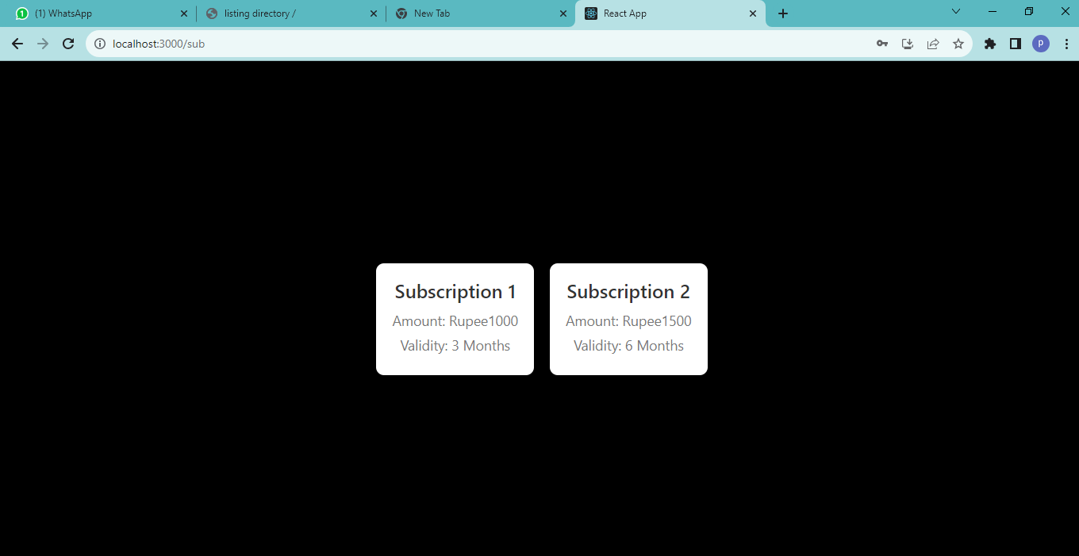

**9. CONCLUSION**

TravelGo provides better platform to book Properties easily ,economically and quickly.

Our System provides a very user-friendly platform where Tourists can easily book Properties with the help of images according to their date and location given by tourists.

Our system will also provide functionalities for host for adding their properties including with images and also choosing the subscription for hosting no of properties. .